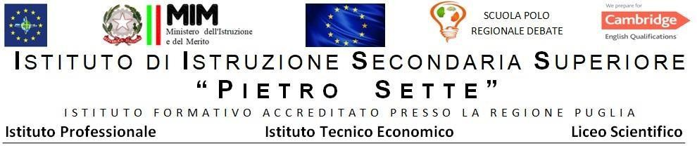

PROGRAMMA DI INGLESE Prof.ssa DE FELICE CATERINA
Classe III A RIM a.s. 2023/2024

Libri di testo: Ben Wetz, Language for Life B2, Oxford
Revellino,Schiraldi,Teiller, Let’s do business in English,Zanichelli

 | Grammar | Vocabulary | Functions
Unit 1 Getting around | - Do/does in positive statements  - Phrasal verb types  - Present tenses: review  - Present perfect with adverbs and for/since | - Everyday travel  - Air travel | - Talking about travel
Unit 2 Food for thought | - Infinitive of purpose v. for +  -ing form  - Ability and permission: review  - Verb patterns | - Cooking  utensils & verbs  - Agriculture | - How to describe an object and its use
Unit 3 Freedom and change | - Possibility and deduction: review  - Past perfect & past perfect continuous  - Narrative tenses: review  - Past simple v. Present perfect: commom errors | - Activism  - Politics | - Resolving conflicts  - How to defend a position
Unit 4 Home sweet home | - Used to v would v Past simple  - Be/Get used to  - Relative clauses  - Reduced relative clauses | - Home  - Factors for happiness | - How to confirm and contradict
Unit 5  Big Future | - Future forms:review  - Future time clauses

From “Let’s do business in English”

The world of business
Unit 04 :business practice
Introducing a company
Writing a business letter
Writing business email
Talking on the phone

Santeramo 07/06/2024

Gli alunni La docente

Caterina De Felice

Santeramo in Colle, 07/06/2024

Gli alunni La docente

De Felice Caterina

